Nepal College of Information Technology
Unit Test
Spring 2011
Program : BE IT Time : 2 hrs
Semester : (II) FM : 70
Subject : Network Theory PM : 35

- Candidates are requested to give their answer as far as practicable in their own words.
- The figure in the margin indicates the full marks
- Attempt ALL question

1. a) In the circuit shown below, the switch K is closed at t=0, a steady state having previously reached. Obtain the current in the circuit as a function of time. 7 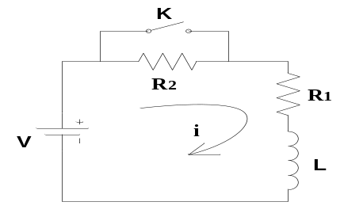
b) In the circuit shown below, the switch is closed at t=0. Find the values of i₁, i₂, di₁/dt, di₂/dt d²i₁/dt², d²i₂/dt² at time t=0+. 8
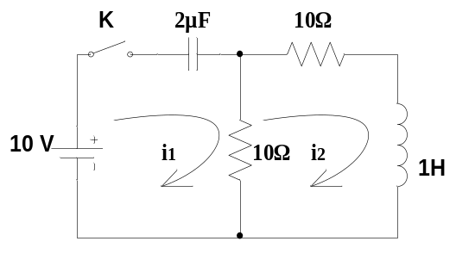
2. a) In a parallel RLC circuit, R=1/7Ω, L=1/12 H, C=1 F and Io=10 amp. The switch K is closed at time t=0. Assuming there is no initial charge across the capacitor and zero current through the inductor. Obtain particular solution for v(t). 7
b) An exponential voltage v(t)= 20e^{-4t} is suddenly applied at time t=0 to a RC series circuit of R= 1Ω and C=0.25 F. Find the particular solution for the current i(t) through the circuit. Assume the steady state condition has reached in the circuit before the voltage is applied. Also calculate the voltage at t=0.2 sec. 8
3. a) What is damping Factor? For a critically damped case in a RLC series circuit Obtain its general and particular solution. [2+6]
b) A sinusoidal voltage 25sin10t is applied at time t=0 to a series R-L circuit comprising R=5Ω, L=1 H. By using Laplace Transform find the current i(t). Assume zero current through the inductor before the application of voltage. 7
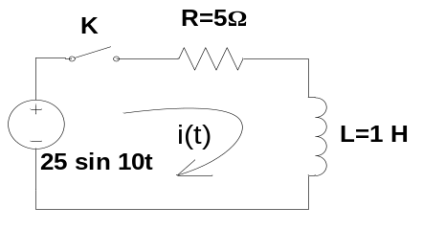

4. a) Find the Laplace transform of the following. 8
i) e^{-at}
ii. u(t-a)
iii. δ(t-t₁)
iv. k.r(t)

b) Using laplace transform, solve the following differential equation for i(t). d²i/dt² + 2di/dt + 4i =8u(t); i(0+) = 3 and di/dt (0+) = -4 7

5. Write short notes on: (Any Two) (5*2=10)
i) Solution of non-homogeneous equation using integrating factor
ii) Time Constant
iii) Unit step signal and its Laplace transform

